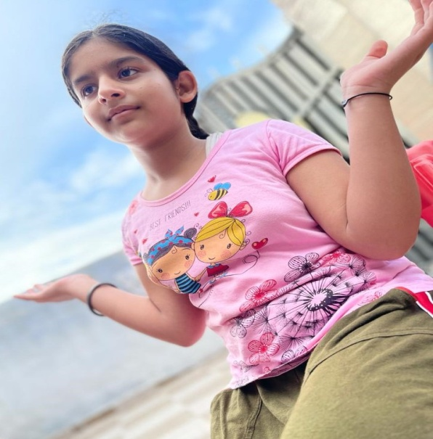
I dream for a new normal world where I live free with all the living beings,
I dream my all wishes comes true everyone lives happily that will comes true.
I dream playing in the garden with all my friends that will comes true
I dream studying with my classmate’s in the school that will comes true
I dream my grandparents go on a walk with me in parks without any fear and that comes true
I dream every person go to their work freely live normal life and that will comes true
I dream no one is hospitalized due to covid and that will comes true
I dream all the holy places open and we all go for worship their and that also come true.
I dream everywhere greenly and water flows pure and that comes true.
I dream everything is going to be ok and that will come true.

THANKYOU
ISHMEET KOUR
CLASS – 6TH -D

